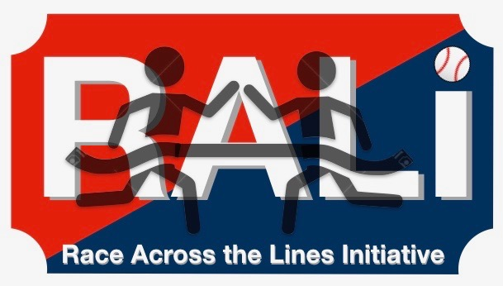

RALI Quiz Bowl Suggested Rules

- After I have finished asking the questions, the first team to hit the buzzer will answer
- Correct answers will result in a point for that team and we will move on to next question
- Incorrect answers will result in a loss of one point
- The questions cover a wide array of topics
- First team to ten correct questions wins, or if we run out of time…
- Winner gets pizza!!
- Losers get other candy

