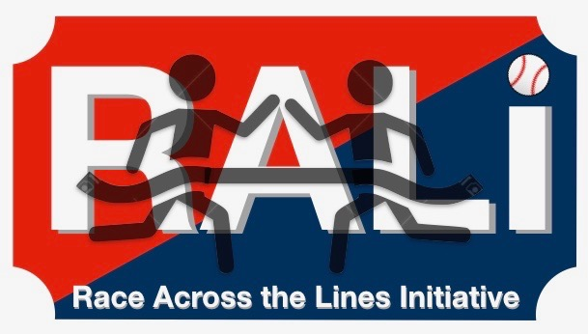

RALI Quiz Bowl Sample Questions

Use these as a guide to help get you started. Some of these questions will not be relevant in your community. Edit, update and add to this Sample to create your own Quiz Bowl Questions:

Q: Who is averaging the most PPG right now in the NBA?
A: James Harden

Q: What is Donald Trump’s middle name?
A: John

Q: Who just won the NCAA national championship?
A: Villanova

Q: What is the largest religion in the world?
A: Christianity

Q: How many capital cities does South Africa have? (bonus points if you can name any)
A: Three: Cape Town, Pretoria, Bloemfontein

Q: Where was Martin Luther King born?
A: Atlanta, Georgia

Q: How many days are in the month of November?
A: 30 days

Q: Which city is home to the Marlins, Heat and Dolphins?
A: Miami

Q: The letter pi is a part of what alphabet?
A: Greek

Q: When was Riverwood established?
A: 1971

Q: In what year did the Civil War begin?
A: 1861

Q: How old is Beyonce?
A: 36 years old

Q: What is Jay –Z’s real name?
A: Shawn Corey Carter

Q: Finish these Gunna lyrics: Audemar wrist, count it then spend it, matted the coupe and _______
A: my windows tinted

Q: How many sides does a heptagon have?
A: 7

Q: Sergio Kitchens, an Atlanta rapper who has close ties to Young Thug is better known by what name?
A: Gunna

Q: What percent of the Earth’s surface is covered in water?
A: 70-75%

Q: What team just upset Barcelona in the Champions League?
A: Roma

Q: What university did Booker T Washington found?
A: Tuskeegee University

Q: What two cities are adjacent to Atlanta Hartsfield Jackson National Airport, besides Atlanta?
A: East point and College Park

Q: Who killed Alexander Hamilton?
A: Aaron Burr

Q: Who purchased Atlanta’s Fort McPhereson in the last couple years?
A: Tyler Perry

Q: Name one of the three men who are pictured in the Stone Mountain Carving.
A: Jefferson Davis, Stonewall Jackson, Robert E. Lee

Q: Name two of the Beetles
A: Ringo Star, George Harrison, John Lennon, Paul Mccartney

Q: Who was the lead singer for the Rolling Stones?
A: Mick Jagger

Q: Who is the head of the NRA?
A: Wayne Lapierre

Q: How many representatives does Georgia have in Congress?
A: 14

Q: Who is the best-selling country artists of all time?
A: Garth Brooks

Q: Where is Pablo Picasso from?
A: Spain

Q: The movie Argo was based off of what real life event?
A: Iranian Hostage Crisis of 1981

Q: What is the SI unit of power?
A: Watt

Q: Who was the leader of the Haitian Revolution?
A: Toussaint L’Ouverture

Q: Who is the founder of the French Impressionist painting movement?
A: Claude Monet

Q: What does ACT stand for?
A: American College Testing

Q: What state is the southernmost part of the Appalachian trail?
A: Georgia

Q: What was the name of Jean Vell Jean’s nemesis in Les Mis?
A: Javer

Q: What is the state vegetable of Idaho?
A: Potatoe

Q: Name the five branches of the U.S. military
A: Army, Navy, Coast Guard, Air Force, Marines

Q: Where was Gatorade created?
A: University of Florida

Q: Who won the SEC football championship in 2017?
A: University of Georgia

Q: What is the new name of the Triple A minor league team for the Atlanta Braves?
A: Gwinnett Stripers

Q: Who is the President of Canada?
A: Justin Trudeau

Q: Who was the third President of the United States?
A: Thomas Jefferson

Q: How many kids does Kanye West have?
A: 3

Q: How many features did J Cole have on his album 2014 Forest Hills Drive?
A: Zero

Q: How many letters are in the Japanese alphabet?
A: 46

Q: Who is the mascot for the University of Maryland?
A: Testudo the Terrapin

Q: What is the most popular name in the world?
A: Muhhamad

Q: Who is the CEO of Amazon?
A: Jeff Bezos

Q: How many weeks are in a year?
A: 52

Q: What colors are on the Irish flag?
A: Green, White, Orange

Q: What is the name of the Boston Red Sox’ baseball park?
A: Fenway Park

Q: Young Thug’s album Barter 6 was previously titled _____ what before a controversy with Lil Wayne?
A: Carter 6

Q: Where did Peyton Manning go to college?
A: University of Tennessee

Q: Who was the first man on the moon?
A: Neil Armstrong

Q: What does NASA Stand for?
A: National Aeronautics and Space Administration

Q: Who wrote The Great Gatsby?
A: F Scott Fitzgerald

Q: What city is the University of Alabama in?
A: Tuscaloosa

Q: Where country is the Black Panther from and what is this country’s natural resource?
A: Wakanda and Vibranium

Q: How many colors are in the rainbow?
A: 7

Q: What is the price of one bitcoin right now?
A: $7,618, accept range from $7,000-$8,000

Q: What continent is Austria in?
A: Europe

Q: Name two of the three highest mountains in the world?
A: Mount Everest, Chimborazo, and K2

Q: What does Volkswagen mean in German?
A: “People’s car”

Q: What country is Pablo Escobar from?
A: Columbia

Q: Who is the player on the NBA logo?
A: Jerry West

Q: On what day of the week is Chickfila closed?
A: Sunday

