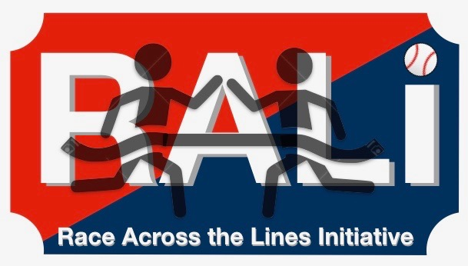

RALI Quiz Bowl Planning Checklist

TWO WEEKS OUT:
- secure convenient time and location
- pick (budget) prizes / incentives _____________
- plan timing and logistics (x kids at y tables, how many rounds)
- find / borrow buzzers

ONE WEEK OUT:
- get the word out
  - text your teammates and friends
  - post on social media (use #RALIEFFECT)
  - post signs / posters at school
- ask a friend (or teacher) to be the official Photographer / Videographer
- start drafting your List of Questions

THREE DAYS OUT:
- personally invite friends and key influencers
- confirm availability of location
- finalize list of questions

DAY OF:
- bring prizes to location
- set up room: separate tables for each team with one buzzer per table
- make a score board on the chalkboard or whiteboard

GAME TIME:
- **split up kids to make diverse teams as they enter the room**
- welcome everyone, thank them for coming, explain the Rules
- ask questions
- keep score
- announce a winner, give out prizes
- take pictures and video
- post to #RALIEFFECT
AFTER THE GAME:
- tell us how it went - send us an email to events@ralieffect.org
- make a YouTube video (optional)
- send us pictures and/or video link for the “Hall of Fame”
- send Press Release and picture to school and local papers
- PASS IT ON!! Encourage at least one friend to host their own RALI Event!

